Step 1: Creating two table loan and borrower with loan number as common column and set this as primary key

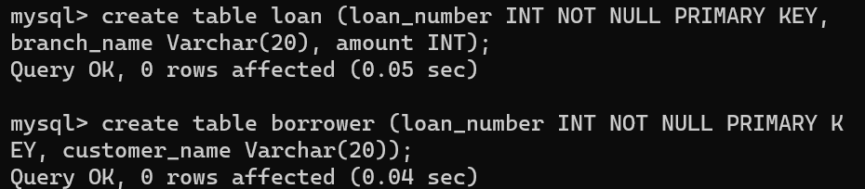

Step 2: Insert values into this table in such a way that (2 must common and 1 unique in each just for better understanding of joins)

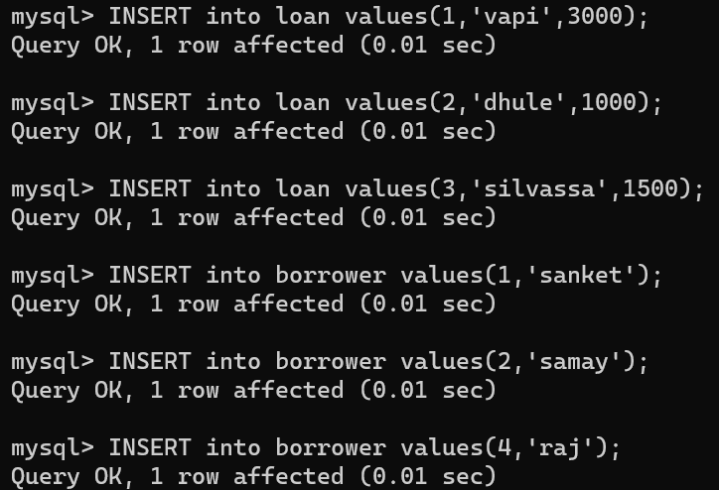

Step 3: look the table you created

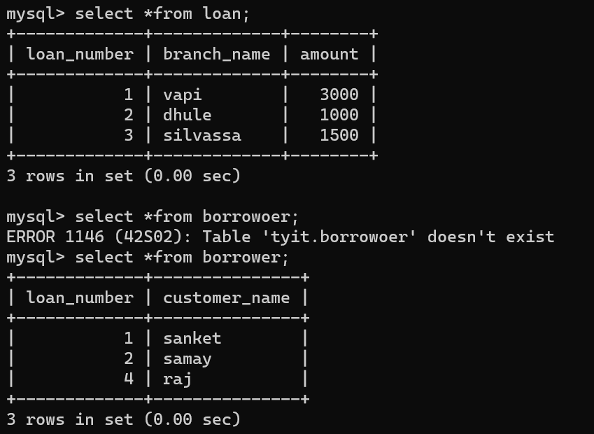

Step 4: Execute inner join, left inner join , right outer join and natural inner join

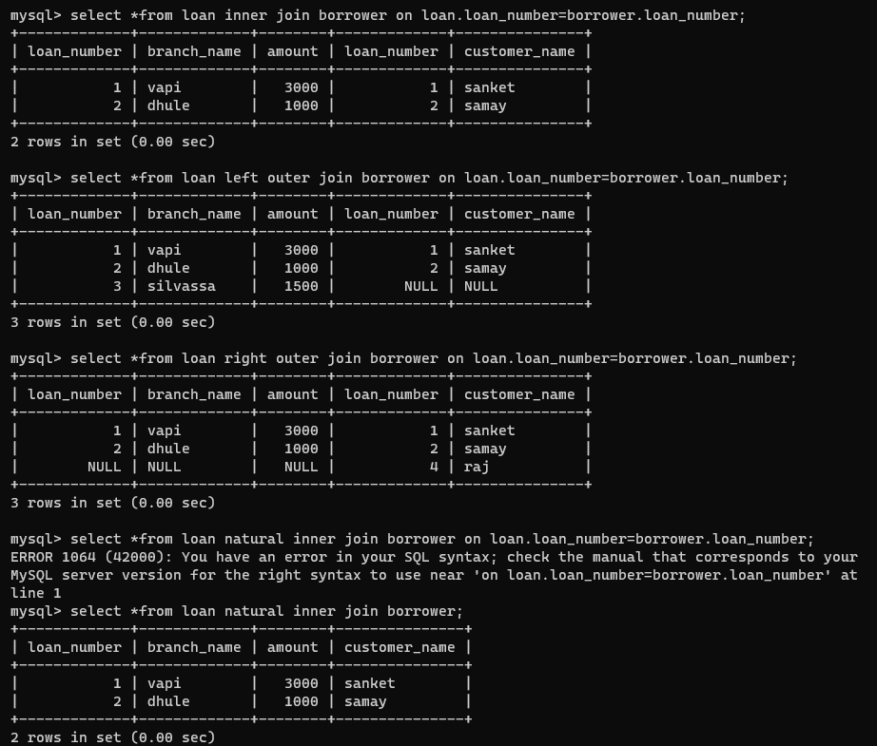

In case of 1 inner join it just consider the tuples which have common loan number in both table

In case of 2 left inner join it consider all the tuple of left and common loan number of left and right

In case of 3 right inner join it consider all the tuple of right and common loan number of left and right

In case of 4 natural join just consider tuple which have common loan number in both table and show loan number of only one table.